Year 4 | Autumn 1 |  | Autumn 2 |  | Spring 1 |  | Spring 2 |  | Summer 1 |  | Summer 2
English  Progress will be supported through our Spellings and Accelerated Reader programme. | Charlie and the Chocolate factory, a fiction text by Roald Dahl. We will know more about writing a descriptive narrative including a story and setting description.  Focusing on commas after fronted adverbials, conjunctions, adjectives, adverbs, punctuation including direct speech, singular & plural nouns and revisiting previously learnt spelling, punctuation and grammar. |  | African Tales, a collection of traditional stories by Gcina Mhlophe. We will know more about diary entries and newspaper reports.  Focusing on reported speech, inverted commas, pronouns to avoid repetition, paragraphs, expanded noun phrases, possessive pronouns and apostrophes of possession. |  | One Plastic bag,, a true story by Miranda Paul. We will know more about formal letters and non-chronological reports.  Focusing on paragraphs, compound words, prepositions, commas for subordinate clauses and plural possessive apostrophes. |  | Jemmy Button, a text based on a true story by Jennifer Uman. We will know more about setting descriptions and recounts.  Focusing on complex sentences, standard English and verb inflections. |  | Ice Palace, a fiction text by Robert Swindells. We will know more about informal letters, note taking and information texts including leaflets.  Focusing on pronouns for cohesion, suffixes and prefixes, homophones and determiners. |  | The Rhythm of the rain is a non-fiction picture book about the water cycle.  We will know more about personal narrative, poetry, visual organisers and writing in role.  Focusing in prepositional phrases and verb tenses (past & present)
Maths | Using White Rose Maths (WRM), we will continue to learn maths through a cumulative approach to the curriculum; once a topic is covered, it is revisited many times again in other contexts. We also make use of WRM’s Flashback 4 which has spaced repetition of key topics throughout and between years to best support our children with their rehearsal and retrieval of maths skills. Our approach will also continue to support the transition from manipulation of concrete objects to pictorial and mental representations, the development of mathematical language and the internalisation of strategies to operate mathematically.  Place Value  Addition and Subtraction Area Multiplication and Division Length and Perimeter Fractions Decimals Money  Time Properties of Shape Statistics Position and Direction
 | 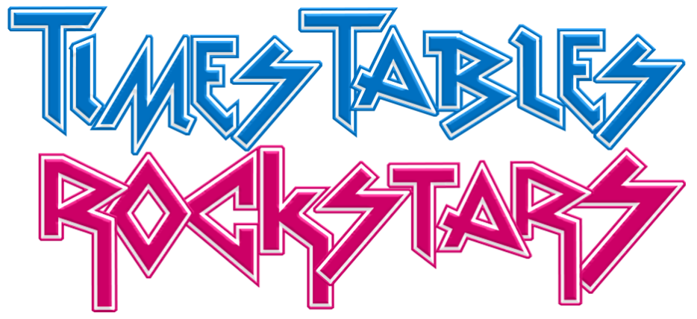 x2 x5 x10 |  | x3 x6 x9 |  | x6 x7 |  | x4 x8 |  | x11 x12 |  | MTC
RE | Domestic Church: People, the family of God in scripture |  | Baptism & Confirmation: Called. confirmation, a call to witness |  | Local Church: Community, life in the local Christian community and ministries in the parish |  | Lent & Easter: Self-Discipline, celebrating growth to new life |  | Reconciliation & Anointing the Sick: Building Bridges. Admitting wrong, being reconciled with God and each other |  | Universal Church: God’s People, different saints show people what God is like
 |  | Judaism: Torah |  | Advent/Christmas: God’s gift of love and friendship in Jesus |  | Eucharist: Giving and Receiving, living in communion |  | Pentecost: New Life, to hear and live the Easter message |  | Islam: Holy books
Science | Animals Including Humans:  -describe the simple functions of the basic parts of the digestive system in humans  -identify the different types of teeth in humans and their simple functions  -construct and interpret a variety of food chains, identifying producers, predators and prey. |  | Living Things and Their Habitats:  -recognise that living things can be grouped in a variety of ways  -explore and use classification keys to hep group, identify and name a variety of living things in their local and wider environment  -recognise that environments can change and that this can sometimes pose dangers to living things |  |  |  | States of Matter  -compare and group materials together, according to whether they are solids, liquids and gases  -observe that some materials change state when they are heated or cooled, and measure or research the temperature at which this happens in degrees Celsius  -identify the part played by evaporation and condensation in the water cycle and associate the rate of evaporation with temperature |  | Electricity:  -identify common appliances that run on electricity  -construct a simple series electrical circuit, identifying and naming its basic parts, including cells, wires, bulbs, switches and buzzers.  -identify whether a lamp will light, in a simple series circuit, or not  -recognise that a switch opens and closes a circuit  -recognise some common conductors and insulators, and associate metals with being good conductors |  | Sound:  identify how sounds are made, associating some of them with something vibrating  -recognise that vibrations from sounds travel through a medium to the ear  -find patterns between the pitch of a sound  -recognise that sounds get fainter as the distance from the sound sources increases
History and Geography | In this unit, the children will explore who the Ancient Egyptians were, what they did, and discuss whether Ancient Egypt deserves its reputation as one of the most important early civilisations |  | Focusing on Geography skills, we will be learning about the Americas and asking can you come on a great American Road Trip? At the end of term, we will create a song or rap about America. |  | Focusing on History skills, we will be learning about Roman Britain and asking was the Roman invasion good or bad for Britain? At the end of term, we will stage a Roman army experience. |  | Focusing on Geography skills, we will be learning about Earthquakes and Volcanoes and asking how does the Earth shake, rattle and roll? At the end of term, we will make a real-life, erupting volcano. |  | Focusing on History skills, we will be learning about Crime and Punishment and asking how has crime and punishment changed over time? At the end of term, we will create a display about the changes in crime and punishment. |  | Focusing on Geography skills, we will be learning about Rivers and the Water Cycle and asking how does the water go round and round? At the end of term, we will make a model river.
Computing | Coding Online Safety Spreadsheets Writing for Different Audiences Logo Animation Effective Searching Hardware Investigation Making Music
Languages  Spanish | Phonics lesson 1&2 and shapes |  | Musical Instruments |  | Weather |  | Family |  | In Class |  | Do you have a pet?
Design Tech |  |  |  |  | ROMAN SHIELDS  (Homework task) |  | Electrical systems: Torches  We will learn about electrical items and how they work, evaluate a range of existing torches and their features, then develop a new functional torch design.  Erupting Volcanoes – Homework |  |  |  | Textiles: Cross-stitch and appliqué  We will learn and apply two new sewing techniques – cross-stitch and appliqué. Utilise these new skills to design and make a cushion.
Art and Design | Craft and design: Ancient Egyptian scrolls. We will be exploring and creating Ancient Egyptian art, guiding pupils in understanding and applying the styles, patterns, and techniques of Ancient Egyptian art through lessons that include designing scrolls, making paper, and creating contemporary responses using zines. |  |  |  | Painting and mixed media: Light and dark. We will be developing skills in colour mixing, focusing on using tints and shades to create a 3D effect. Experimenting with composition and applying painting techniques to a personal still life piece.  Linked to English topic
Music |  |  | Body & tuned percussion (Rainforests) |  | Adapting & transposing motifs (Romans) |  |  |  | Samba & Carnival sounds and instruments |  | Changes in Tempo & Dynamics (Rivers)  Arts week
PE | Gym |  | Net Games - Games |  | Dance |  | Invasion Games |  | Striking & Fielding |  | Athletics - Games
PSHE | Created and Loved by God  Created and Loved by God explores the individual. Rooted in the teaching that we are made in the image and likeness of God, it helps children to develop an understanding of the importance of valuing themselves as the basis for personal relationships.  Me, My Body, My Health  In this Unit, children will learn to celebrate similarities and differences, and to appreciate and look after their bodies as gifts from God. Teaching also covers specific physical and emotional changes during puberty, and that growing from boys and girls to men and women is part of God’s loving plan for creation. |  | Emotional Well-Being and Life Cycle  Emotional Well-Being helps children to understand the difference between feelings and actions, how to manage them and what they can do to help themselves stay emotionally healthy. In this Unit, media is discussed as a ‘fake reality’ and God’s love for us is presented as a better basis for our self-confidence. Finally, children will identify unacceptable behaviours and learn to build resilience against negative feelings by practising thankfulness. |  | Life Cycles  Returning to the story of Jairus’ daughter from Unit 1, Unit 4 – Life Cycles explores the miraculous nature of human conception and birth and offers an opportunity for thanksgiving. Death and life after it is further discussed, alongside the complexities of grief where children will consider ways to support themselves and others. The unit is concluded by children reflecting on change now they are older. Feelings around big changes will feature, and children will learn how to prepare for new changes, including some coping strategies and how we can learn to rely on the constancy of God. |  | Created to Love Others  Created to Love Others explores the individual’s relationship with others. Building on the understanding that we have been created out of love and for love, this module explores how we take this calling into our family, friendships and relationships, and teaches strategies for developing healthy relationships and keeping safe both online and in our daily lives. |  | Keeping Safe  Keeping Safe features teaching on physical, emotional and sexual abuse through a series of animated stories. Children will explore in more detail what to do in emergency situations. A mini series of Classroom Shorts also highlights key areas of safety when out and about. The final session of the module identifies legal rights and considers how our responsibilities relate to these. This is underpinned by the religious understanding that we all play a part in the Body of Christ. |  |  | Created to Live in Community  Created to Live in Community explores the individual’s relationship with the wider world. Here we explore how human beings are relational by nature and are called to love others in the wider community through service, through dialogue and through working for the Common Good. In Life to the Full Plus, further exploration of careers and money lead to understanding that true happiness comes from knowing God’s love and finding our identity and worth in Him.
Home Learning | 10 Garages (TTRS) Monday to Monday| Spellings (Monday to Monday)

