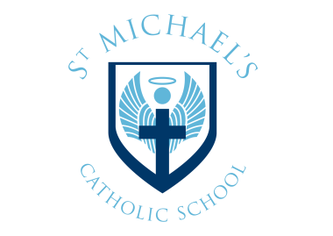

Certificate Collection Information for Students

Certificates are available for collection, as follows; if you are unable to collect certificates, please complete the form below.

| **Date(s)** | 25th November 2024 to 31st March 2025 | **Time(s)** | 8 – 3.30 pm |
| --- | --- | --- | --- |
| **Collection point** | School Reception | **Identification must be provided on collection** | |

**Checking certificates**

On collection, you should carefully check that your personal information (name, date of birth, etc.) is correct and that the correct final grade(s) issued to you is/are shown. You will be required to sign that you have collected your certificates and confirm they are correct.

**Uncollected certificates**

Certificates are retained for a period of 12 months from date of issue, after which they are disposed of confidentially and you would have to request copies from the relevant examining board. In case of query, please contact Mrs Watson on 01494 535196 or exams@stmichaelscs.org

------------------------------------------------------------------------------------------------------------Candidate permission form

If you are unable to collect certificates in person, please indicate below your preferred method by clicking on the link below and completing the required information:

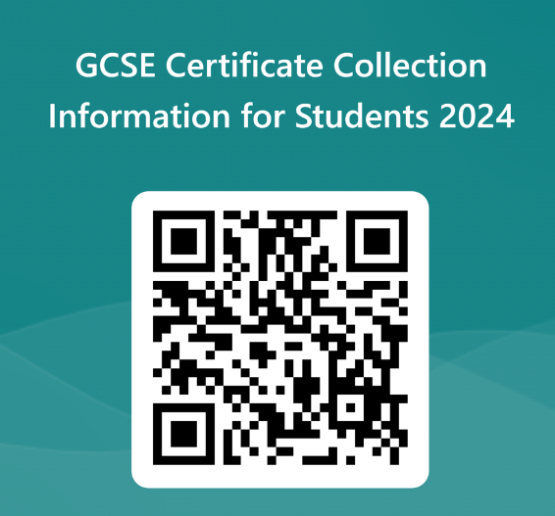<https://forms.office.com/e/yqAxdeaZwY>

\**Certificates will be sent to the address held on record at the centre. Any change of address should be notified to reception. St Michael’s does not take any responsibility for certificates sent out to addresses where this process has not been followed.*